# Chapter 2

Chapter 2 1

Introduction 2

The question of biodiversity 2

Methods 4

Data collection 4

Taxonomic effort 4

Data analysis 4

Results 7

Description rates 7

Taxonomic effort 7

Parasite to non-parasite comparison 8

Discussion 13

Discovery rates 13

Taxonomic effort 14

How many marine parasitic species are there? 15

1 in 5 marine species are parasite 16

References 18

# Introduction

## The question of biodiversity

With increased access to an unprecedented amount of data, there has been a renewed effort to try and determine the age old question of “How many species are there on this planet?” (Appeltans *et al.*, 2012; Costello, May and Stork, 2013a; Poulin, 2014; Strona and Fattorini, 2014; Poulin and Presswell, 2016; Costello and Chaudhary, 2017). These studies indicate that approximately two-thirds of species on Earth have been described, with the effort in these descriptions being at its highest rate ever recorded – whether that be due to the total number of taxonomists (Costello, Wilson and Houlding, 2013) or increased collaborations between remaining taxonomists and subject experts (Poulin and Presswell, 2016). However, there are many taxa that are still highly underrepresented in these estimates; for example, parasites (Appeltans *et al.*, 2012).

Parasitism has evolved 223 times in 15 of 35 recognised animal phyla (Weinstein and Kuris, 2016), and it is predicted that parasitic organisms hold one third to half of all biodiversity on the planet (Toft, 1986; Dobson *et al.*, 2008; Poulin, 2014). These predictions are founded on the assumptions that parasites are highly host specific and that a host can harbour more than one parasitic species (Poulin and Morand, 2004). There is also hyper-parasitism, where parasites have adapted to live off other parasites (Lucius and Poulin, 2017). However, analysis of global data on parasite diversity found that at present, parasites of animals comprise only 5% of named species (Costello 2016).

There have been many discussions into why there is this lack of description; particularly referencing their cryptic lifestyle, lack of research in large biogeographic regions, predicted hyper diversity, paucity of specifically parasite taxonomists, unrecognized synonyms and under-sampling even within well studied taxa (e.g. birds, elasmobranchs) (Rohde, 2002; Dobson *et al.*, 2008; Randhawa and Poulin, 2010; Caira and Jensen, 2014; Costello, 2016; Poulin, 2016; Costello and Chaudhary, 2017). By their very nature, parasites are well concealed on or within their hosts, do not occur uniformly throughout a host population, and may have few easily distinctive morphological features, which makes their identification and discovery difficult (Poulin and Morand, 2004). Therefore, are our predictions of one parasite species per host species an overestimate or is this discrepancy due to gross under-sampling and/or a misidentification of parasites?

In this chapter, I review progress in the discovery of marine parasitic species and compare their rates of discovery to non-parasitic marine species for reference. This is done by collating the available information within collaborative open access databases and building the largest marine parasite database to date. This chapter then plots the rate of description of these two groups of animals, the number of authors involved, and the relative number of species per author per decade. These patterns provide the basis for considering whether the rates of discovery of marine parasites are catching up to their non-parasitic marine counterparts. Finally, I tested to see if there was a covariance between the rates of discovery between non-parasitic marine species and marine parasites as these two groups of animals are intrinsically linked. This finding may provide insight into how many species of marine parasites are still out there awaiting description.

# Methods

## Data collection

Parasites are a polyphyletic group. They represent an assembly of organisms that have evolved independently in separate lineages. Therefore, to download a full species list of “all parasites”, as defined in Chapter 1, requires an integrated approach. Taxa (e.g., class, order, family, genus) identified as having chiefly marine parasites were selected and their downstream species were downloaded from the World Register for Marine Species (WoRMS) (Horton *et al.*, 2019) and the Global Biodiversity Information Framework (GBIF) Backbone Taxonomy (GBIF Secretariat, 2017)(Table 1).

Numbers of free-living marine taxa were collected by downloading full species lists from WoRMS (Horton *et al.*, 2019), and subtracting previously identified marine parasitic taxa. All above lists were downloaded using the *taxize* (Chamberlain *et al.*, 2018) packages in R. Both marine datasets were cross referenced with the WoRMS dataset using the *worrms* (Chamberlain and Scott, 2019) package in R to determine that all species being analysed are extant “*isExtinct ≠ 1*”, are marine species “*is.marine = 1*” and that their species names are accepted “*status = accepted*”.

The authority values for each species record in WoRMS was parsed for the year value in which the original description of that species can be found. It is this value that is used as the year of description throughout the following analyses.

## Taxonomic effort

The number of first authors describing species was plotted yearly. Authority values were downloaded with the above dataset and, using the *stringr* package (Wickham, 2019), separated the first author from the authority value (if more than one author was present). Thus, the recent trend for an increasing number of authors describing one species did not affect author counts and underestimates the number of people naming new species. In cases where different authors had the same surname, I found the original descriptions to distinguish them from their given names. If this was not possible, I counted a surname for 50 years from first occurrence. Number of descriptions per year divided by the number of first authors of that year was used as a proxy for taxonomic effort.

## Data analysis

Generalised additive modelling (GAM) was used to explore the relationship between marine parasites and non-parasitic marine species rates of description. GAMs fit non-parametric smoothing functions to covariates in a model and allow comparisons between trajectories of the response variable with respect to other factors without the need to fit particular functions to the data. I fitted individual GAMs to each of the description rates with a negative binomial error distribution. Additionally, Restricted Maximum Likelihood (REML) was used to determine effective degrees of freedom with gamma set to a value of 1.4. Setting gamma to 1.4 forces models to be a little “smoother” than they might otherwise be and is an ad hoc way of avoiding overfitting (Wood, 2017). Finally, once models were fitted and their assessments displayed models conforming to statistical assumptions, a chi squared test was used to test for differences between these models. All GAMs were drawn through the *mgcv* (Wood, 2017) and *gratia* (Simpson, 2020) packages.

I compared rates of description for non-parasitic species with marine parasitic species of the same year to determine if there were any trends in this relationship. It is assumed that parasitic rates of discovery are determined by the rates of discovery in their hosts as you need to describe the host before you can describe its parasite (Poulin and Morand, 2004). A GAM was used to find a trend and this data and was then split in 50 year increments from 1750 to 2020 to see if there are any changes in this trend over time.

All analysis was conducted in R environment (R Core Team, 2019) with the use of tidyverse (dplyr, readr, stringr, ggplot2), along with above mentioned packages.

|  |  |  |  |  |
| --- | --- | --- | --- | --- |
| Table 1: Major groups of metazoan taxa and their habitat (endoparasitic or ectoparasitic) and the number of parasitic species within these taxa present in online datasets WoRMS and GBIF Taxonomy Backbone. (updated and adapted from Poulin and Morand, 2004; Rohde, 2005; Blaxter and Koutsovoulos, 2014; Costello, 2016; Weinstein and Kuris, 2016). | | | | |
|  | |  | Minimum Number of | |
| *Marine Parasitic Taxa* | |  | Parasitic Habitat | Parasitic Species |
| Phylum Arthropoda |  | |  |  |
| Class Arachnida | Ixodida, Mesostigmata, Sarcoptiformes, Trombidiformes | | ecto | 1044 |
| Class Hexanauplia |  | |  |  |
| SubClass Copepoda | Monstrilloida, Siphonostomatoida | | ecto | 2122 |
| SubClass Thecostraca | Ascothoracida, Cirripedia (Rhizocephala, Thoracica) | | ecto | 416 |
| Class Ichthyostraca | Branchiura, Pentastomida | | ecto/endo | 255 |
| Class Insecta | Phthiraptera, Siphonaptera | | ecto | 3071 |
| Class Malacostraca |  | |  |  |
| Order Amphipoda | Hyperiidea, Cyamidae | | ecto | 317 |
| Order Isopoda | Cymothooidea, Cryptoniscoidea, Bopyroidea | | ecto | 2155 |
| Phylum Mollusca |  | |  |  |
| Class Gastropoda | Triviidae, Ovulidae, Eulimidae, Epitoniidae, Pyramidellidae, Architectonicidae, Cypraeidae | | ecto/endo | 3641 |
| Phylum Acanthocephala |  | | endo | 686 |
| Phylum Annelida | Hirudinea | | ecto | 198 |
| Phylum Nematoda | Chromadoria (Rhabditida, Monhysterida),  Enoplea (Dioctophymatida, Enoplida, Trichinellida) | | endo | 4142 |
| Phylum Platyhelminthes |  | |  |  |
| SubPhylum Neodermata |  | |  |  |
| Class Cestoda |  | | endo | 1904 |
| Class Monogenea |  | | ecto | 3644 |
| Class Trematoda |  | | endo | 5996 |
| Phylum Chordata | Echeliophis, Petromyzontiformes, Simenchelys | | ecto/endo | 46 |
| Phylum Tardigrada | *Tetrakentron* *synaptae*, *Pleocola* *limnoriae*, *Echiniscoides* *hoepneri* | | endo | 3 |
| Phylum Cnidaria | Myxozoa | | endo | 655 |
| Phylum Dicymida |  | | endo | 122 |
| Phylum Orthonectida |  | | endo | 26 |
|  |  | |  |  |
| ***TOTAL*** |  | |  | 30 443 |
| 1 lice parasitizing marine birds | | | | |

# Results

In total, 30 443 species of marine parasites were included in the dataset (Table 1). These data were spread across 11 phyla, and 23 classes within those phyla. The functional group ‘helminths’ (Acanthocephala, Nematoda, and Platyhelminthes) constitute 52% of species within the dataset. Combined with the next two largest groups, 31% Arthropoda and 12% Mollusca. The final 3% of species that make up the dataset constitute minor groups including Orthonectida, Diceymida, Myxozoa, and three species of Tardigrada. Many of the Chordata and a few Arthropoda species that are included in this dataset are considered as ‘hit and run’ feeders or micropredators (Rohde, 2005), but still fulfil the definition of parasite as they feed off a host at some stage of its life without the intention of killing it.

A total of 199 057 marine species were downloaded from WoRMS and the 27 699 parasitic species were removed from that dataset. This resulted in a dataset of 171 358 marine non-parasitic species. Therefore, of all marine species currently in the WoRMS dataset, 14 % of them are parasitic.

## Description rates

Rates of description were based on the year of publication for that species (from the species authority description) and were totalled yearly for the three downloaded datasets from the years 1758 until 2020 (Figure 1). The earliest descriptions in this dataset are a product of Carl Linnaeus from his early publication *Systema Naturae Vol. 10* (1758), where he described 4,400 species of animal, including 732 non-parasitic marine species and 37 marine parasites. These data show that from the early 1800’s until a century later, marine non-parasite description rates steadily outpaced those of marine parasites (df = 1; Chi Sq = 1506; p < 0.001).

Both marine non-parasites and marine parasites experienced a dramatic drop in description rate during both the World Wars (WWI 1914-1918, and WWII 1939 - 1945). However, description rates quickly recovered, and surpassed levels seen before these global events.

## Taxonomic effort

There has been an increase in the number of authors over time describing species (Figure 1). This increase is more pronounced for non-parasitic species than parasitic species (df = 1; Chi Sq = 7433; p < 0.001). Fewer non-parasitic marine species are being described in proportion to the number of authors (taxonomic effort) (Figure 1), yet marine parasites have remained constant. These results indicate that taxonomic effort has remained relatively stable for marine parasites, yet is on the decline for marine non-parasitic species (Df = 1; Chi Sq = 142; p < 0.001).

Within parasitic taxonomic groups, molluscs and platyhelminth’s have had the majority of descriptions, with intermittent peaks throughout history (Figure 2). The helminth’s peaked later in the 1970’s but their rates have been steadily declining since then. Arthropods have steadily increased since the early 1800’s with a peak in the 1980’s. Of the three major taxonomic groups of parasites, molluscs peaked earliest in the late 1950’s and have seen a resurgence in discovery in the last 20 years. Accordingly, more ectoparasites have been described than endoparasites (endo: 13813 , ecto: 13886), but this difference is very small. Between the 1920’s and 1970’s, endoparasitic descriptions outpaced those of ecto parasitic descriptions, but have been declining from the 1970’s and ectoparasitic discoveries have remained constant. (Figure 2).

## Parasite to non-parasite comparison

With an increase in marine species discovery rates, there is similar increase in marine parasite discoveries, although at a 1:5 parasite to non-parasite species ratio (MarineParasites = 0.19 MarineSpecies - 22.07, r2 = 0.67, p<0.001) (Figure 3). If we break these rates across half century time periods, we see this relative increase in both description rates for every 50 year period until the 1990s (Figure 4). This is represented by the positive trend line and points migrating upward and to the right in each successive period. However, since the 1990’s, in the current 50 year period, marine non-parasite description rates are outpacing those of marine parasites.

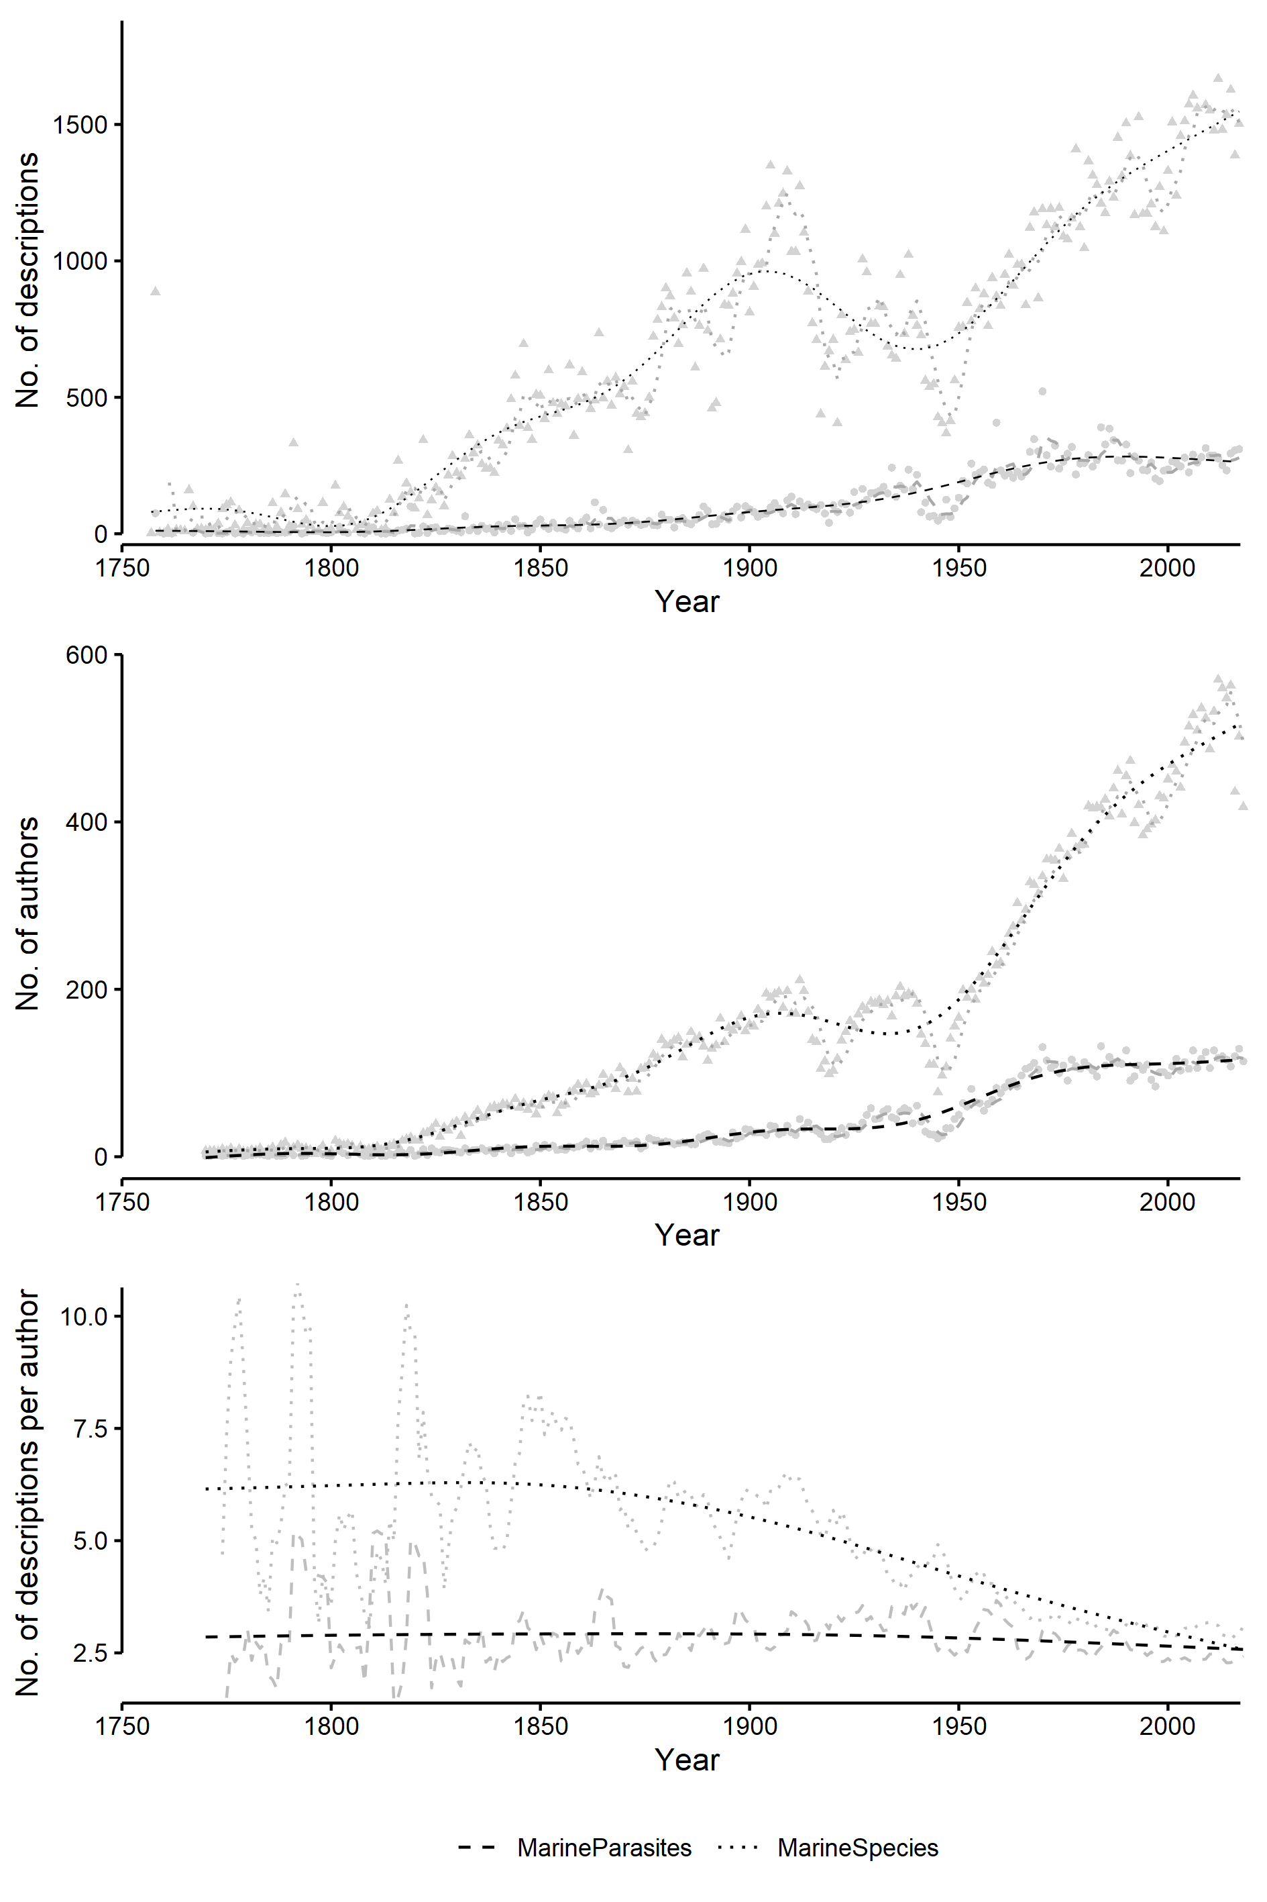

Figure 1: (a) Total number of species descriptions (b) Total number of first authors per species description (c) Total number of species descriptions per year divided by total number of first authors per species description for marine parasites (dashed line) and marine species (excluding parasites (dotted line), per year. Grey lines indicate 5 year moving average, black line indicates GAM.

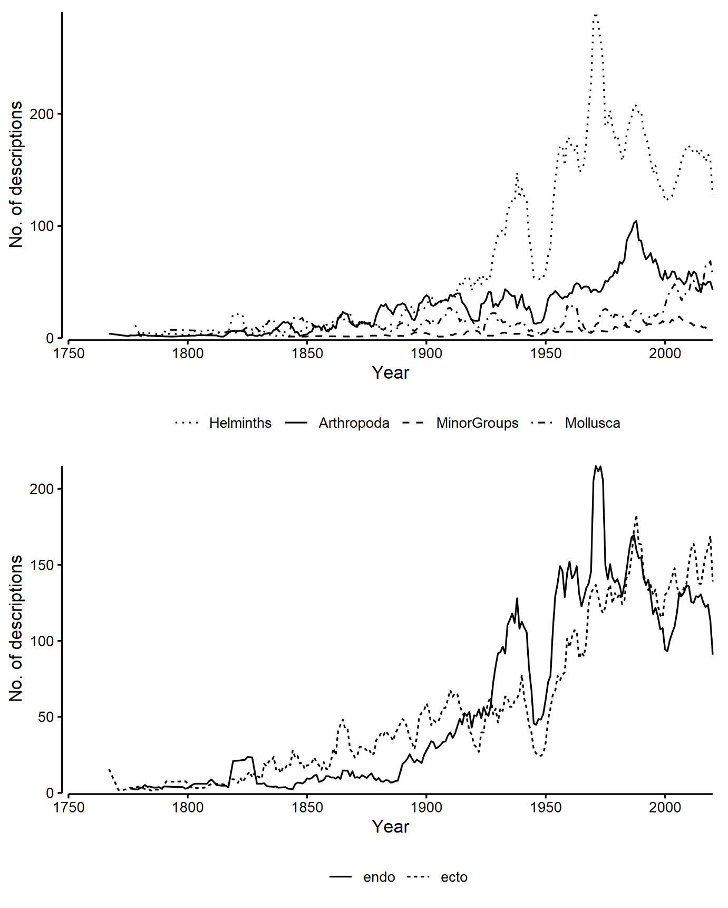

Figure 2: Total number of marine parasite species descriptions divided into (a) taxonomic groups and (b) habitat. Lines are 5 year moving averages.

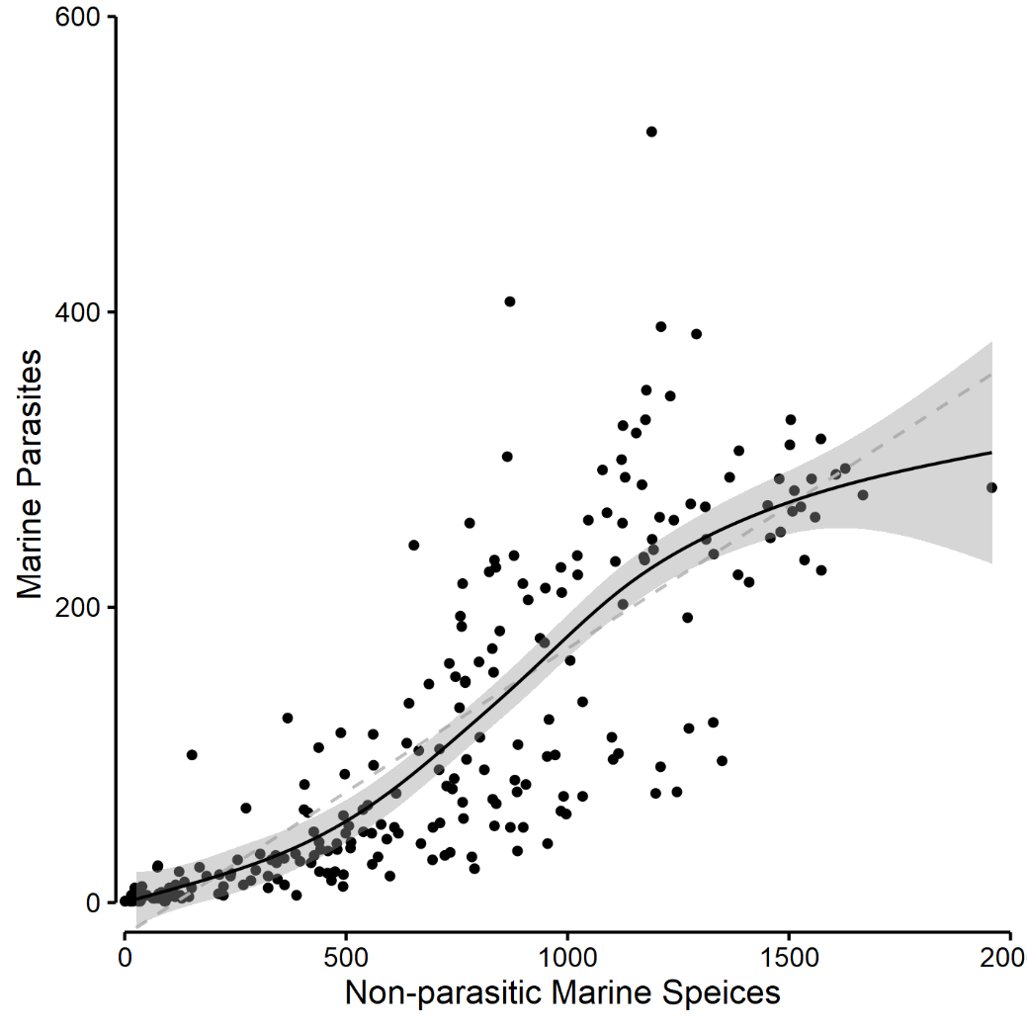

Figure 3: Relationship of marine parasites to Marine species. Linear model (dashed line) (y=0.19x-22.071909, r2 0.67, p<0.001) and GAM (solid line) (y ~ sx, smoothing function = cubic squares), ( F = 2.838, eDF = 4.209, r2 0.69, p<0.001) with shaded 95% confidence interval. Difference between the two is significant to p = 0.001, eDF; lm = 243, gam = 237.91.

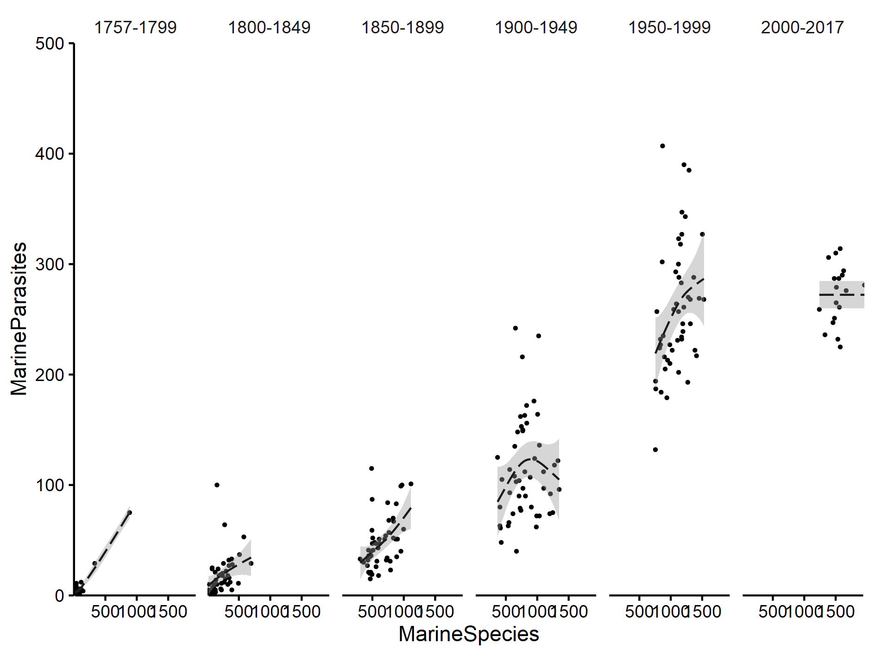

Figure 4: Relationship of marine parasites to marine species across half century time periods from 1756 to 2017. Shaded grey areas are 95% confidence intervals. F = 45.72, eDF = 2, r^2 =0.875

# Discussion

Despite the significance of parasite biodiversity, the actual richness of most macroparasitic groups remains uncertain, due to a combination of underlying statistical challenges and universal data limitations for symbiont taxa (Carlson *et al.*, 2020). By reviewing global databases for parasites and establishing a baseline of taxonomic and systematic knowledge, research gaps can be identified and effort applied to allow ecological and evolutionary research to be conducted from a firm foundation.

Therefore, the aim of this chapter is to review current open access global species databases for the presence of parasites. We collate this data and analyse the rate of progress in the naming of marine parasitic species and compare their rates of description with those of marine non-parasitic species. The resulting trends were compared to trends in taxonomic effort by their respective authors. These rates of description were analysed across taxonomic and functional groups of marine parasites to determine which key groups require increased taxonomic focus. Finally, I tested to see if there was a covariance between the rates of discovery between non-parasitic marine species and marine parasites as these two groups of animals are intrinsically linked.

## Discovery rates

It is unsurprising that non-parasitic marine species are out pacing the rates of discovery for marine parasites (Poulin, 2014; Costello, 2016). The species to be first described tend to be more widespread, contribute to human welfare (positively or negatively), occur on land or in shallower depths (i.e., coastal regions), and are near or in more developed countries (e.g., northern hemisphere) (Costello *et al.*, 2015; Costello, 2016; Carlson *et al.*, 2020; Poulin, Presswell and Jorge, 2020). Some of these species have captured our imaginations and therefore research effort has focussed on these charismatic species (Donaldson *et al.*, 2016). Additionally, some of the best studied parasites are those that infest humans, domestic animals and animals of commercial relevance (Dobson *et al.*, 2008).

By their very nature, parasitic species are cryptic, and are therefore expected to be discovered only after their hosts have been discovered (Poulin and Morand, 2004). They do not occur uniformly throughout a host population making discovery and study of these species difficult. Additionally, many taxa and functional groups (for example the monogenean and larval cestodes) lack easily distinctive morphological features making identification and description difficult. It is for these, and probably many other reasons that marine non-parasitic species enjoy a greater focus with respect to general research effort and hence, their description.

In analysing trends in rates of description for parasite species in both marine and terrestrial realms, Costello (2016) found that most parasitic molluscs, crustaceans, ticks, fleas, and insects may already be named, with decreases in the rates of description since the year 2000. For helminths and microsporidians, Costello (2016) found the peak discovery period occurred in the 1970s. In general, my results support these finding with peaks in arthropod and helminth discovery in the late 1900’s but differ in description rates of marine molluscs. Costello (2016) found that molluscs peaked in the mid 1900’s, yet my results suggest intermittent peaks from the mid 1800’s to the late 1900’s with a resurgence in discovery within in the last 30 years. These discrepancies may be due to an update in description records in accessible databases in the four years between this and Costello’s (2016) publication.

With respect to taxonomic groups, helminths are large, charismatic parasites that occur consistently throughout their host species populations which explains why they have such high and consistent discovery rates. Arthropods are large external parasites that can easily be seen on the surface of their hosts, making discovery and identification easier. Finally, mollusc/gastropod descriptions have seen a recent increase in the last 30 years. This is probably due to the use of DNA sequencing aided in realizing the presence of many cryptic species and the effort of some key authors (Dgebuadze, Fedosov and Kantor, 2012; Queiroz *et al.*, 2017).

As expected, initially, ectoparasites have enjoyed increased taxonomic effort compared to endoparasites, due to the ease in which sampling can be done on these animals. With the invention and common use of the compound microscope in the early 1900’s though, endoparasite descriptions increased and surpassed those of external parasites. Yet, in this dataset, numbers of description have remained quite consistent between these two groups over the last 30 years.

## Taxonomic effort

Taxonomic effort follows the same trends as description rates, with the number of authors describing marine species outpacing those of marine parasites. But, the number of descriptions per author show a gradual decrease from the 1800’s for marine non-parasitic species. This could be due to an increase in the number of marine taxonomists initially. More recently though, it could be due to species discoveries becoming more difficult (Costello, Wilson and Houlding, 2013). That marine parasites have remained constant could be due to the uniqueness of the field and it not experiencing a wealth of taxonomists. Also, as parasites span the animal kingdom, many taxonomist focus on one phylum or functional group, not crossing taxonomic groups (Poulin and Presswell, 2016).

In figure 3, I compare marine species rates of discovery with those of marine parasites of the same year and drew a linear model with a significant slope of 0.2. Therefore, for approximately every five non-parasitic marine species described per year, one marine parasite species is described. Additionally, when we divide this relationship up into 50 year time periods from 1750, there’s a significant “upper limit” to the number of parasites that are discovered compared to their non-parasitic counterparts. For example, from the 1900’s, when non-parasitic species reach 900-1500 species discoveries per year, parasite rates of description begin to plateau, at about 250 - 300 descriptions.

This upper limit might be a reflection of taxonomic capacity (e.g.: 120 taxonomists describing 3 parasites, on average, per year), yet, reported taxonomic effort has been inconsistent. Poulin, (2014) and Poulin and Presswell, (2016) report an increase in the number of descriptions per author for helminth parasites from 1980 to 2014. Conversely, Costello, (2016) reports consistent taxonomic effort for helminths and increasing effort for crustaceans and molluscs. If we average taxonomic effort across all marine parasitic species, our results show that effort has remained consistent throughout time. Differences in my results compared to established literature is due to a difference in the data used, with Poulin’s work focussing on helminth parasites of vertebrates (irrespective of environment; marine, freshwater and terrestrial) and our dataset being almost double that of Costello’s dataset.

Additionally, if we look deeper at the rates of discovery across taxa, results are showing an inflection point in descriptions for marine helminths in the 1970’s and the same for marine parasitic arthropods in the 1980’s. This is probably an indication that species discoveries are becoming more difficult, following in the steps of marine non-parasitic species (Costello, Wilson and Houlding, 2013). An indication that discovery is reaching an inflection point is by witnessing an inverse relationship with body size and year of discovery. This has already been shown in parasitic copepods (Poulin, 1996), in cestodes infesting elasmobranchs (Randhawa and Poulin, 2019), and in helminth worms in general (Carlson *et al.*, 2020).

## How many marine parasitic species are there?

As simple as this question might seem, the answer to it is anything but straight forward. The many predictions estimating current parasite numbers or predicting numbers of unknown species still to be discovered have an overwhelming focus on helminth parasites of vertebrate hosts (Poulin and Morand, 2000; Dobson *et al.*, 2008; Strona and Fattorini, 2014; Costello, 2016; Poulin and Presswell, 2016; Poulin and Pérez-Ponce de León, 2017; Jorge and Poulin, 2018; Poulin, Presswell and Jorge, 2020). These studies use a variety of methods to estimate these numbers; from collating expert opinion, developing a variety of models and using cumulation curves. The results of these are as variable as the methods used with predictions ranging from 5% of known species are parasites to a predicted half of all species on earth are parasitic.

However, these predictions pool analysed data across environments (e.g.: terrestrial, freshwater, marine). Research has shown that parasitic speciation is different between these environments due to their intrinsic physical differences. For example, Poulin, (2016) showed higher rates of speciation in parasites of freshwater hosts than those of marine hosts. This is supported by Poulin and Pérez-Ponce de León, (2017) who show that freshwater species hold more cryptic richness than either terrestrial or marine environments. Therefore, by pooling predictions across environments, we are shielding the effects that these environments may have on these predictions.

One of the common methods for predicting parasite richness is based on the scaling between host and parasite richness, a near-universal pattern across spatial scales and taxonomic groups. Kamiya *et al.*, (2014a, 2014b) showed that species richness of parasites is strongly correlated with that of their hosts. Therefore, as marine non-parasitic species are intrinsically linked with their potential hosts, or non-parasitic marine species in this study, we believe that marine parasites constitute 20% of known marine species. This is due to the consistent flattening in the GAM model and the slope variable in Figure 3. Additionally, of all marine species currently in the WoRMS dataset, 14 % of them are parasitic.

## 1 in 5 marine species are parasite

Why do I believe that only 20% of marine species are parasitic?

*Hosts are not equal in their suitability for parasites*

The best studied parasites are those of vertebrates. These species tend to have large body-sizes and are geographically widespread, thereby providing multiple parasite microhabitats and increased chance for infection. Yet, vertebrates are not representative of all species on Earth. Over 61% of marine species on Earth are arthropods and other macro-invertebrates (Costello, May and Stork, 2013b). Their small body size is a more limiting resource for parasites (Oliva and Alvarez, 2011) than larger vertebrates and they are often used as intermediate hosts to complete parasitic lifecycles (Leung, Mora and Rohde, 2015). Therefore … what are you trying to say…

*New discoveries will not alter the global pattern*

Global patterns of non-parasite species are showing that new discoveries will not alter the global pattern. Biogeographic research on non-parasitic marine species is showing that we do not expect new species discoveries to alter the global pattern of species richness and their biogeography (Costello and Chaudhary, 2017; Jorge and Poulin, 2018). Therefore, we expect that parasitic discoveries in these areas will mirror the patterns of non-parasitic species as patterns in spatial variation of parasite species richness tend to match those already well-documented for free-living species (Poulin, 2014; Jorge and Poulin, 2018). This suggests that as further species are described from the marine environment, we expect to find species that are more localized in their distributions, and/or hosts in the case of parasites.

*Better to infect more host species than few.*

The co-evolutionary tension between parasites and their hosts create unique selection pressures as they continually adapt to survive (Hudson, 2005). These evolutionary moves and counter-moves have been shown to create highly specialized parasitic organisms, that are uniquely adapted to their host or hosts (Poulin, 2007). However, with the incorporation of molecular and experimental techniques in determining host specificity in parasites, results have revealed that parasites can often infect many more hosts successfully than is seen in nature (Poulin and Keeney, 2007). This is a better evolutionary strategy as most species are geographically rare and rare hosts provide limited opportunities for parasite transmission and evolution.

In conclusion, marine non-parasitic rates of description are out pacing those of their parasites at a rate of one to five. Taxonomic effort has remained consistent through time even with an increase in the number of taxonomists describing parasitic species. That research has shown that not all hosts are equal in their suitability as hosts, that current trends in marine species discovery will not alter the global pattern of species distribution, the only explanation for the results we see is that parasites are more host generalist than what we currently believe. Host-specificity will be addressed in chapter 3.

These results do not mitigate the importance that parasites play within ecosystems, nor does it mitigate the importance of the research currently being done in the field. Exactly how current patterns of disease and parasite distribution and prevalence are likely to change over the coming decades with predicted changes in climate has been described as one of the most pressing theoretical questions in epidemiology (Pickles *et al.*, 2013; Carlson *et al.*, 2017), and one we hope will receive increasing attention as we try to mitigate and adapt to the impacts of a changing climate.

# References

Appeltans, W. *et al.* (2012) ‘The Magnitude of Global Marine Species Diversity’, *Current Biology*, 22, pp. 2189–2202. doi: 10.1016/j.cub.2012.09.036.

Blaxter, M. and Koutsovoulos, G. (2014) ‘The evolution of parasitism in Nematoda’, *Parasitology*, 142, pp. S26–S39. doi: 10.1017/S0031182014000791.

Caira, J. N. and Jensen, K. (2014) ‘A digest of elasmobranch tapeworms’, *The Journal of Parasitology*, 100(4), pp. 373–391.

Carlson, C. J. *et al.* (2017) ‘Parasite biodiversity faces extinction and redistribution in a changing climate’, *Scientific Advances*, 3(e1602422), pp. 1–12. doi: 10.1126/sciadv.1602422.

Carlson, C. J. *et al.* (2020) ‘What would it take to describe the global diversity of parasites?’, *PNAS*, pp. 1–10. doi: 10.1073/pnas.XXXXXXXXXX.

Chamberlain, S. *et al.* (2018) ‘Taxize - Taxonomic Information from Around the Web’.

Chamberlain and Scott (2019) ‘Package “worrms”’.

Costello, M. J. *et al.* (2015) ‘Factors influencing when species are first named and estimating global species richness’, *Global Ecology and Conservation*, 4, pp. 243–254. doi: 10.1016/j.gecco.2015.07.001.

Costello, M. J. (2016) ‘Parasite rates of discovery, global species richness and host specificity’, *Integrative and Comparative Biology*, 56(4), pp. 1–12. doi: 10.1093/icb/icw084.

Costello, M. J. and Chaudhary, C. (2017) ‘Marine Biodiversity, Biogeography, Deep-Sea Gradients, and Conservation’, *Current Biology*, 27, pp. R511–R527. doi: 10.1016/j.cub.2017.04.060.

Costello, M. J., May, R. M. and Stork, N. E. (2013a) ‘Can we name earth’s species before they go extinct?’, *Science*, 339, pp. 413–416. doi: 10.1126/science.1230318.

Costello, M. J., May, R. M. and Stork, N. E. (2013b) ‘Response to Comments on “Can We Name Earth’s Species Before They Go Extinct?”’, *Science*, 341, pp. 237-d. doi: 10.1126/science.1237381.

Costello, M. J., Wilson, S. and Houlding, B. (2013) ‘More Taxonomists Describing Significantly Fewer Species per Unit Effort May Indicate That Most Species Have Been Discovered’, *Systematic Biology*, 62(4), pp. 616–624. doi: 10.1093/sysbio/syt024.

Dgebuadze, P. Y., Fedosov, A. E. and Kantor, Y. I. (2012) ‘Host specificity of parasitic gastropods of the genus Annulobalcis Habe, 1965 (Mollusca, Gastropoda, Eulimidae) from crinoids in Vietnam, with descriptions of four new species’, *Zoosystema*, 34(1), pp. 139–155. doi: 10.5252/z2012n1a6.

Dobson, A. *et al.* (2008) ‘Homage to Linnaeus : How many parasites ? How many hosts ?’, *PNAS*, 105, pp. 11482–11489.

Donaldson, M. R. *et al.* (2016) ‘Taxonomic bias and international biodiversity conservation research’, *FACETS*, 1, pp. 105–113. doi: 10.1139/facets-2016-0011.

GBIF Secretariat (2017) *GBIF Backbone Taxonomy*, *Checklist dataset*. Available at: https://doi.org/10.15468/39omei accessed via GBIF.org on 2018-2019.

Horton, T. *et al.* (2019) *World Register of Marine Species (WoRMS)*. WoRMS Editorial Board. Available at: http://www.marinespecies.org.

Hudson, P. J. (2005) ‘Introduction - Parasites, diversity, and the ecosystem’, in Thomas, F., Renaud, F., and Guegan, J. (eds) *Parasitism and Ecosystems*. Oxford, UK.: Oxford University Press, p. 221.

Jorge, F. and Poulin, R. (2018) ‘Poor geographical match between the distributions of host diversity and parasite discovery effort’, *Proceedings of the Royal Society B: Biological Sciences*, 285, p. 20180072. doi: 10.1098/rspb.2018.0072.

Kamiya, T. *et al.* (2014a) ‘Host diversity drives parasite diversity: Meta-analytical insights into patterns and causal mechanisms’, *Ecography*, 37, pp. 689–697. doi: 10.1111/j.1600-0587.2013.00571.x.

Kamiya, T. *et al.* (2014b) ‘What determines species richness of parasitic organisms? A meta-analysis across animal, plant and fungal hosts’, *Biological Reviews*, 89, pp. 123–134. doi: 10.1111/brv.12046.

Leung, T. L. F., Mora, C. and Rohde, K. (2015) ‘Patterns of diversity and distribution of aquatic invertebrates and their parasites’, in Morand, S., Krasnov, B. R., and Littlewood, D. T. J. (eds) *Parasites Diversity and Diversification: Evolutionary Ecology Meets Phylogenetics*. Cambridge, United Kingdom: Cambridge University Press, pp. 39–57.

Lucius, R. and Poulin, R. (2017) ‘General Aspects of Parasite Biology’, in *The Biology of Parasites*. 2nd edn. Weinheim, Germany: Wiley-VCH Verlag GmbH & Co., p. 472.

Oliva, M. E. and Alvarez, C. (2011) ‘Is a vertebrate a better host for a parasite than an invertebrate host? Fecundity of Proctoeces cf lintoni (Digenea: Fellodistomidae), a parasite of fish and gastropods in northern Chile’, 109, pp. 1731–1734. doi: 10.1645/GE-2004.1.

Pickles, R. S. A. *et al.* (2013) ‘Predicting shifts in parasite distribution with climate change: a multitrophic level approach’, *Global Change Biology*, 19, pp. 2645–2654. doi: 10.1111/gcb.12255.

Poulin, R. (1996) ‘How many Parasite Species are there: Are we Close to Answers?’, *International Journal for Parasitology*, 26(10), pp. 1127–129.

Poulin, R. (2007) *Evolutionary Ecology of Parasites*. 2nd edn. Princeton, New Jersey, USA, New Jersey, USA: Princeton University Press.

Poulin, R. (2014) ‘Parasite biodiversity revisited: frontiers and constraints’, *International journal for Parasitology*, 44(9), pp. 581–589.

Poulin, R. (2016) ‘Greater diversification of freshwater than marine parasites of fish’, *International Journal for Parasitology*, 46, pp. 275–279. doi: 10.1016/j.ijpara.2015.12.002.

Poulin, R. and Keeney, D. B. (2007) ‘Host specificity under molecular and experimental scrutiny’, *Trends in Parasitology*, 24(1), pp. 24–28. doi: 10.1016/j.pt.2007.10.002.

Poulin, R. and Morand, S. (2000) ‘The diversity of parasites’, *The Quarterly Review of Biology*, 75(3), pp. 277–293.

Poulin, R. and Morand, S. (2004) *Parasite Biodiversity*. Washington, DC: Smithsonian Institution Press.

Poulin, R. and Pérez-Ponce de León, G. (2017) ‘Global analysis reveals that cryptic diversity is linked with habitat but not mode of life’, *Journal of Evolutionary Biology*, 30(3), pp. 641–649. doi: 10.1111/jeb.13034.

Poulin, R. and Presswell, B. (2016) ‘Taxonomic Quality of Species Descriptions Varies over Time and with the Number of Authors, but Unevenly among Parasitic Taxa’, *Syst. Biol*, 65(6), pp. 1107–1116. doi: 10.1093/sysbio/syw053.

Poulin, R., Presswell, B. and Jorge, F. (2020) ‘The state of fish parasite discovery and taxonomy: a critical assessment and a look forward’, *International Journal for Parasitology*, xxx(xxx). doi: 10.1016/j.ijpara.2019.12.009.

Queiroz, V. *et al.* (2017) ‘The gall-former Sabinella troglodytes (caenogastropoda: Eulimidae) and its association with Eucidaris tribuloides (echinodermata: Echinoidea)’, *Journal of Conchology*, 42(5), pp. 371–377.

R Core Team (2019) ‘R: A language and environment for statistical computing. R Foundation for Statistical Computing’. Vienna, Austria.

Randhawa, H. S. and Poulin, R. (2010) ‘Determinants of tapeworm species richness in elasmobranch fishes: untangling environmental and phylogenetic influences’, *Ecography*, 33, pp. 866–877. doi: 10.1111/j.1600-0587.2010.06169.x.

Randhawa, H. S. and Poulin, R. (2019) ‘Tapeworm discovery in elasmobranch fishes: quantifying patterns and identifying their correlates’, *Marine and Freshwater Research*. doi: 10.1071/MF18418.

Rohde, K. (2002) ‘Ecology and Biogeography of Marine Parasites’, *Advances in Marine Biology*, 43, pp. 1–83.

Rohde, K. (2005) *Marine Parasitology*. Edited by K. Rohde. Collingwood, Australia: CSIRO.

Simpson, G. L. (2020) ‘gratia: Graceful ’ggplot’-Based Graphics and Other Functions for GAMs Fitted Using “mgcv”. R package version 0.3.1.’

Strona, G. and Fattorini, S. (2014) ‘Parasitic worms: How many really?’, *International Journal for Parasitology*. Australian Society for Parasitology Inc., 44(5), pp. 269–272. doi: 10.1016/j.ijpara.2014.01.002.

Toft, C. A. (1986) ‘Communities of parasites with parasitic life-styles’, in Diamond, J. M. and Case, T. J. (eds) *Community ecology*. New York: Harper & Row, pp. 445–463.

Weinstein, S. B. and Kuris, A. M. (2016) ‘Independent origins of parasitism in Animalia’, *Biology Letters*, 12, p. 20160324. doi: 10.1098/rsbl.2016.0324.

Wickham, H. (2019) ‘stringr: Simple, Consistent Wrappers for Common String Operations.’

Wood, S. J. (2017) *Generalized Additive Models: An Introduction with R (2nd edition)*. 2nd Editio. Chapman and Hall. doi: 10.1201/9781315370279.